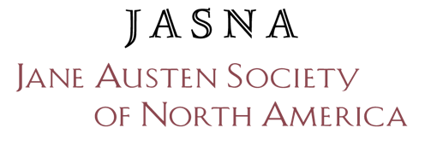
Jane Austen Book Box
Project Report

All schools and organizations receiving Jane Austen Book Boxes must submit a report on the implementation and results of their project. Accompanying photos and/or videos are encouraged and much appreciated, as long as there are no identifiable images of minors. Signed copies of the JASNA Photo/Video Release Form will be required from any adults (18+) who are identifiable in a photo/video as well as from the photographer.

Project Contact
Name:
Address:
Email Address: Phone:
Name of Your School/Organization:
Organization’s Address:
School/Organization Website or Facebook Page:
School Principal/Organization Director:

Project Details
Start and end date of project:
Number of students who participated:
Age/Grade-level of students:
Description of students who received the books (e.g., ethnicity, reading-level, first-language):

How were the books given away to the students? (Please be specific.) If any of the books were kept by your organization, what are your future plans for them?

Description of your project or program and the results (please be specific):

What are your plans for follow up? Can JASNA help you?

Other Comments:

Printed Name: Date:

Signature: ________________________________________________________________________

Please email your report and any photos or videos to JABookBox@jasna.org.

Thank You!

